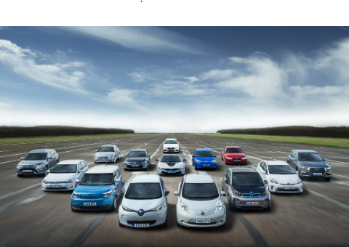**Visualization Tool for Electric Vehicle Charge and Range Analysis**

**1.INTRODUCTION**

**1.1 OVERVIEW**

A vehicle that can be powered by an electric motor that draws electricity from a battery and is capable of being charged from an external source and have an electric motor instead of an internal combustion engine.

The Electric Vehicle (EV) is not new, but it has been receiving significantly more attention in recent years. Advances in both EV analytics and battery technologies have led to increased automotive market share. However, this growth is not attributed to hardware alone. The modern mechatronic vehicle marries electrical storage and propulsion systems with electronic sensors, controls, and actuators, integrated closely with software, secure data transfer, and data analysis, to form a comprehensive transportation solution. Advances in all these areas have contributed to the overall rise of EV’s, but the common thread that runs through all these elements is data analytics.

The new EV’s are combined Electrical storage and propulsion systems with electronic sensors, controls, and actuators, integrated closely with software, secure data transfer to form a comprehensive transportation solution.

**1.2 PURPOSE**

E**lectric vehicles** offer a glimmer of hope. They eliminate exhaust emissions, reduce dependence on fossil fuels, improve community health, ensure energy security, and improve employment and training prospects. Linking **electric** mobility with renewable energy **goals** will decarbonize the transport sector.

**2. PROBLEM DEFINITION & DESIGN THINKING**

**2.1 EMPATHY MAP **

**2.2 IDEATION & BRAINSTORMING MAP**



**3. RESULT**

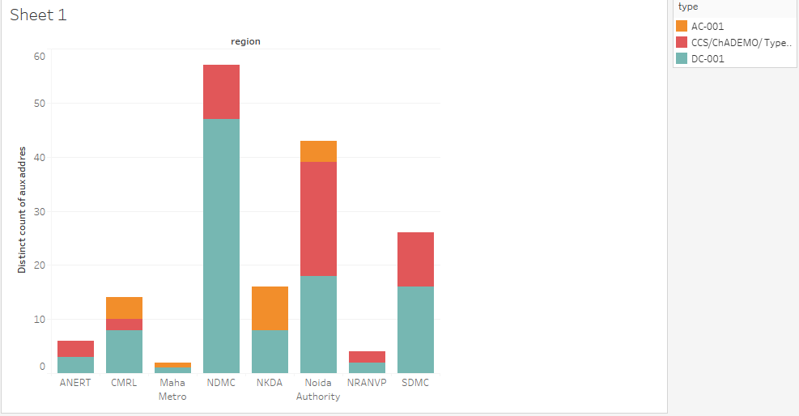

Team leader:https://trailblazer.me/id/sanie6

Team member 1:https://trailblazer.me/id/preml9

Team member 2:https://trailblazer.me/id/renur13

Team member 3:https://trailblazer.me/id/rakij



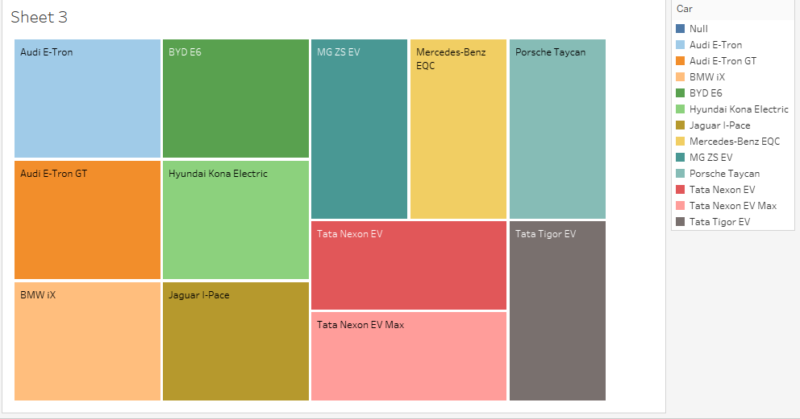

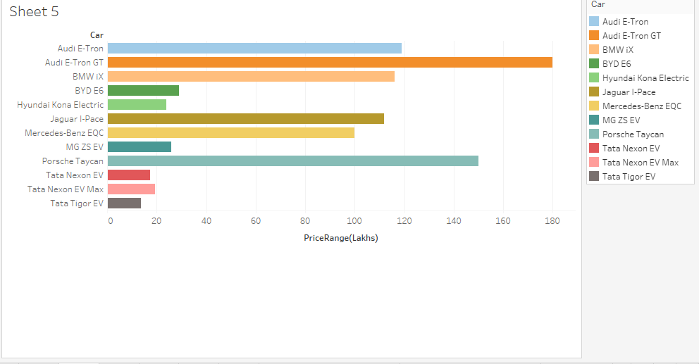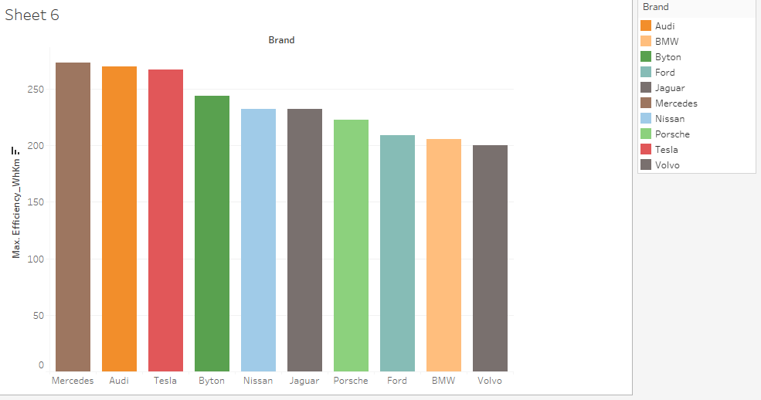



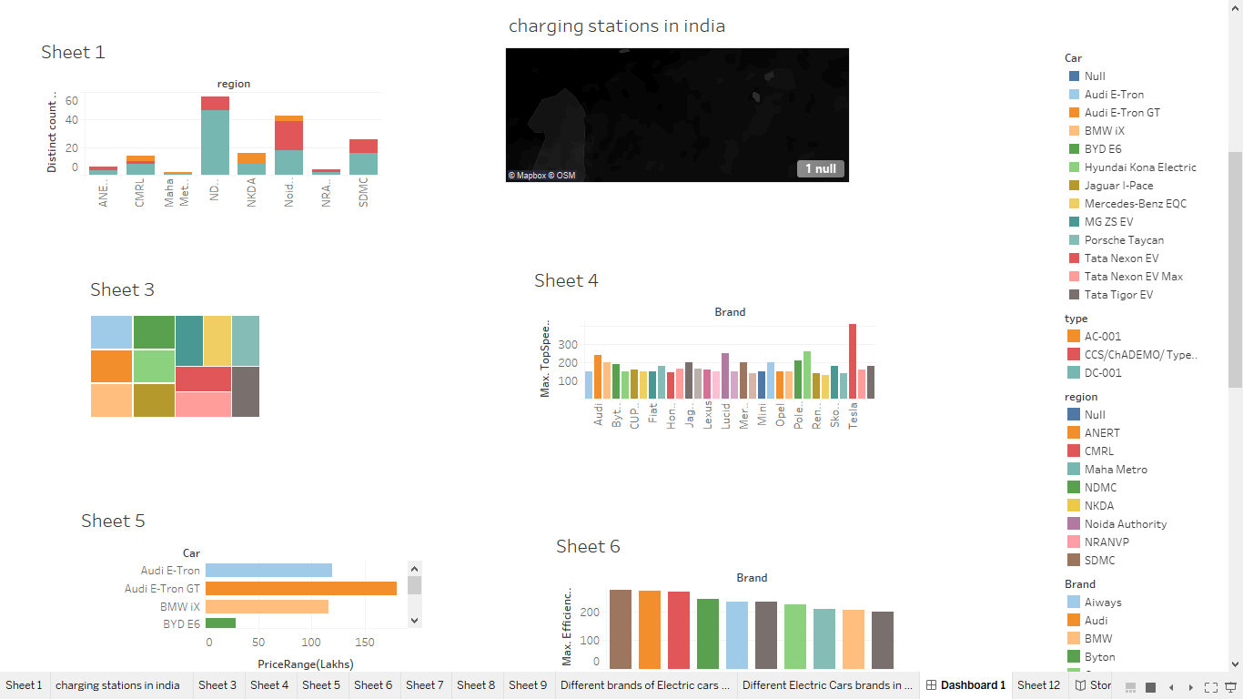



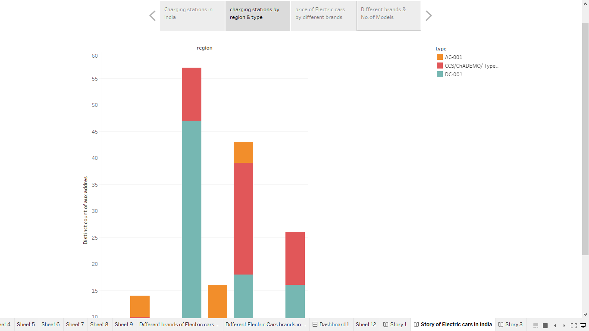

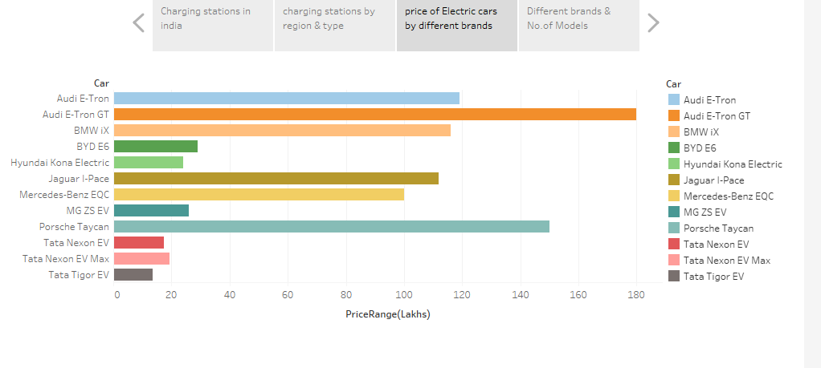

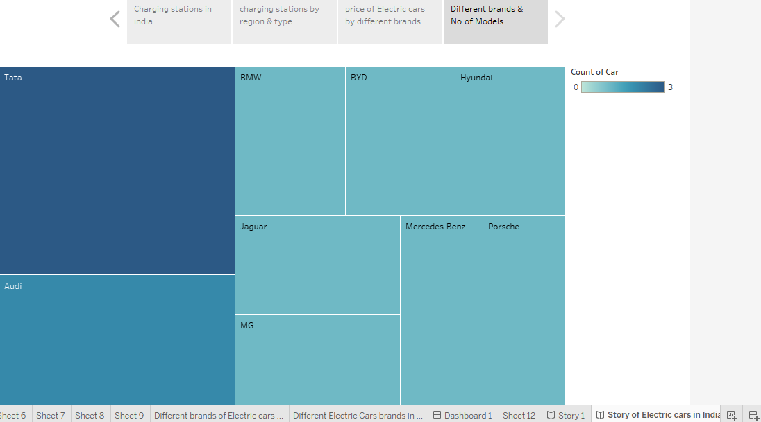

**4. ADVANTAGES AND DISADVANTAGES**

**ADVANTAGES**

* The use of electric vehicles is increasing due to their environmental benefits. They do not release any harmful substances into the air. They have zero emissions which is better for the environment.
* Electric vehicles are also much quieter than traditional vehicles.
* Electric vehicles also have a much lower maintenance cost than traditional cars as they do not need oil changes or tune-ups.
* They can be charged at home, making it easier for people living in an urban areas with no parking space.
* They are more efficient than gas-powered automobiles.
* We will save money on fuel costs, which can be a massive advantage for people who have long commutes or live in areas where the gas price is high.
* It is easier for electric vehicles to get up hills and accelerate quickly from stop lights.

DISADVANTAGES

* **High initial cost:**Electric vehicles continue to be quite expensive, and many buyers believe they are not as inexpensive as traditional automobiles.
* **Charging station limitations:** People who need to travel long distances are concerned about finding adequate charging stations in the middle of their journey, which are not always accessible.
* **Recharging takes time:** Unlike conventional automobiles, which require only a few minutes to replenish their gas tanks, charging an electric vehicle takes many hours.
* **Limited options:**Currently, there aren’t many electric car models to pick from in terms of appearance, style, or customized variations.
* **Less driving range:**When compared to conventional automobiles, electric vehicles have a shorter driving range. Electric cars can be convenient for short-distance travel but are inconvenient for long-distance travel.

5.APPLICATIONS

* **Personal transportation**

EVs are becoming increasingly popular as an alternative to gasoline-powered cars for personal transportation.

* **Fleet transportation**

Many government agencies and companies are incorporating EVs into their fleets for more sustainable and cost-effective transportation.

* **Delivery and courier services**

EVs are ideal for short-distance delivery services as they are quiet and emission-free.

* **Public transportation**

Buses, trains, and trams powered by electricity are becoming increasingly common in cities for low-emission public transportation.

* **Industrial and commercial applications**

EVs are used in a variety of industrial and commercial applications, such as material handling equipment, airport ground support vehicles, and maintenance vehicles.

* **Off-road vehicles**

Electric ATVs, motorcycles, and dirt bikes are gaining popularity for off-road recreation and work applications.

* **Energy storage systems**

EVs can be used as mobile energy storage systems to help stabilize the grid and provide backup power during outages.

6.CONCLUSION

Electric vehicles (EVs) are a promising technology for achieving a sustainable transport sector in the future, due to their very**low to zero-carbon emissions, low noise, and high efficiency**. Nonetheless, the large penetration of EVs is expected to affect the existing power grids, due to high loads. The progress that the electric vehicle industry has seen in recent years is not only extremely welcomed, but highly necessary in light of the increasing global greenhouse gas levels. As demonstrated within the economic, social, and environmental analysis sections of this webpage, the benefits of electric vehicles far surpass the costs. The biggest obstacle to the widespread adoption of electric-powered transportation is cost related, as gasoline and the vehicles that run on it are readily available, convenient, and less costly. As is demonstrated in our timeline, we hope that over the course of the next decade technological advancements and policy changes will help ease the transition from traditional fuel-powered vehicles. Additionally, the realization and success of this industry relies heavily on the global population, and it is our hope that through mass marketing and environmental education programs people will feel incentivized and empowered to drive an electric-powered vehicle. Each person can make a difference, so go electric and help make a difference!

7.FUTURE SCOPE

The future potential of electric vehicles is enormous. The obvious starting point for these vehicles is thecharging station. This is however only the first step in a potential journey which will see charge Banks and other industrial areas as well as homes and cities. The future scope of electric vehicles is therefore massive.

The technology for electric vehicles has been around since the 70’s in labs such as NASA. The present day technology will no doubt be far more advanced in a few years time. Some believe that we will soon see electric vehicles that can power themselves by harvesting energy from their environment. Such vehicles will require very little maintenance and can even run off alternative energy sources such as wind.

One problem faced by electric vehicles is that they do not fit into many parking spaces. As advances are made in technology, this problem will seem to be lessened with time. Other obstacles are also that electric vehicles use electricity which results in a pollution issue. There are solutions though, for both these issues. The charging stations for electric vehicles offer a way in which pollution can be reduced and also help to create jobs in regions where employment is little.

The future scope of electric vehicles is therefore enormous. We have already seen that technology for these vehicles is here and becoming far more advanced. We now know that such vehicles can provide us with great flexibility and we will soon see that potential.

It will also be interesting to see the impact of regulations which will come into force from the EU and US. These regulations are set to reduce petrol engine vehicles use. As electric vehicles grow in popularity, so will the need to reduce their use. It is clear that there will be a need to develop new zero emission technologies.

This study provides a detailed information on the future scope and the historical data analysis. It concludes by looking at the present prospects and gives a good guide as to how far technology has come. Future scope is estimated to continue growing rapidly as electric vehicles become more popular. More detailed information can be found in the full report which is available to download from the website. This provides an outline of the main points covered in the report.

The market research report provides a comprehensive overview of the current trends in the global market. It discusses the present day technology, the outlook for the future and the position of electric vehicles in this market segmentation. The analysis looked at four key areas. These are power source, battery technology, charging systems and the regional analysis.

Power source is one of the most important aspects and the global market segmentation is analysed with detailed information. The present day electric vehicles are using different sources such as the wind power, solar power and hydroelectric power. Most of these technologies have evolved in Africa. Some of the countries which have developed these technologies are Morocco, South Africa, Tanzania, Namibia, Zimbabwe and Brazil. It should be noted that these nations all have very low fuel costs and this means that it is very affordable to install a charging system on the cars.

Batteries have been the primary concern all over the world. With the development in technology, lithium-ion batteries are replacing the ordinary alkaline batteries. This has posed a serious challenge to the manufacturers. The market research report offers details on the major key players of this industry and the various plans that are taken by them to overcome the challenges.

The third area in which the report outlines the future scenario is the charging systems. Most of the vehicles today have an electrical charge system. It is the electricity consumption by the user that determines the size of the battery pack. The global market segmentation gives details on the charging systems and the reasons why the manufacturers have decided to adopt these or not.